**ICT LAB06 LAB TASK**

**Name:- Yash Raj**

**Roll number:- 24k-0737**

**Task#1:-**

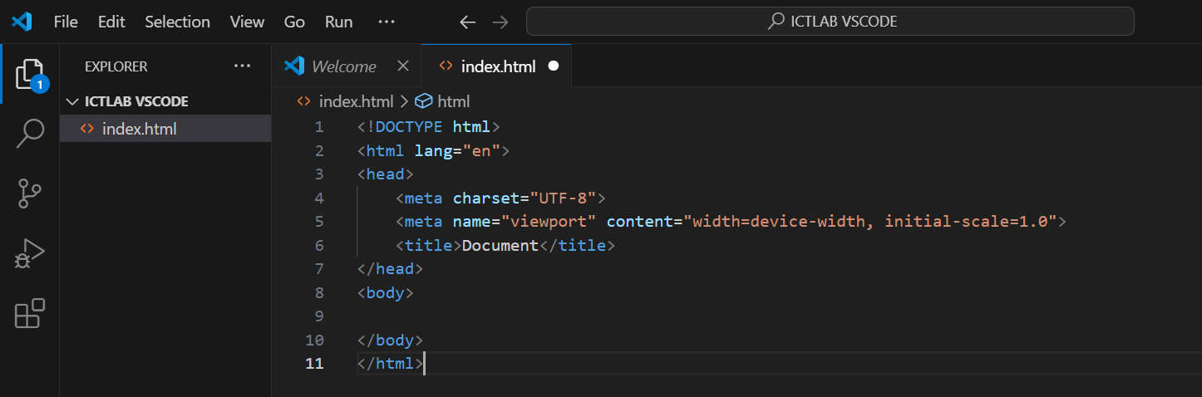

**Task#2:-**

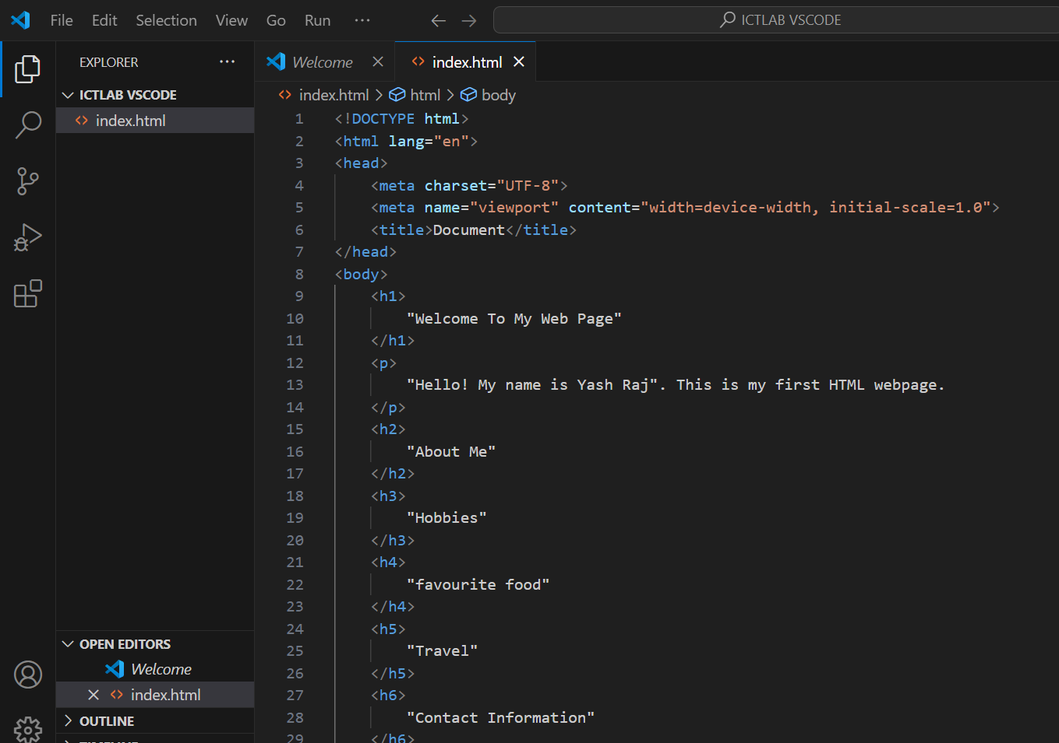

**Task#2 website view:-**

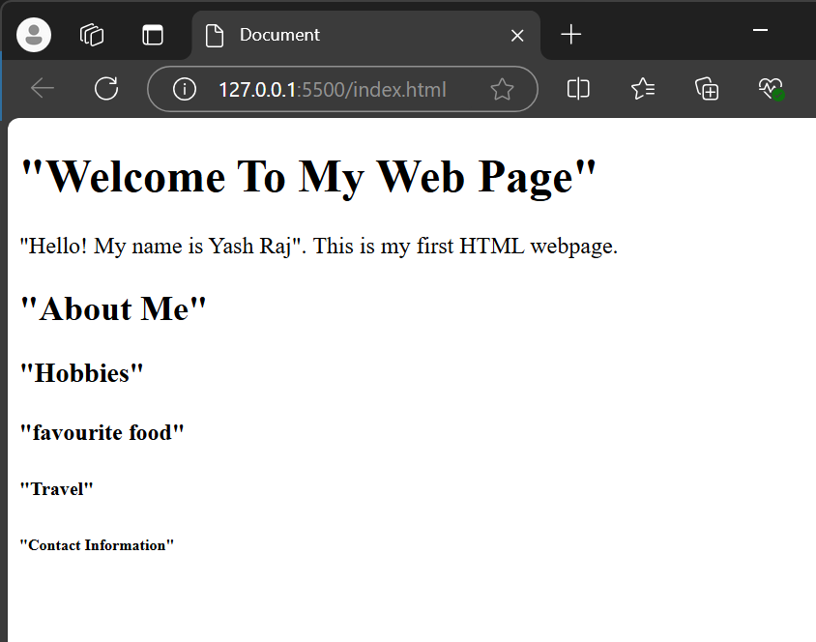

**Task#3:-**

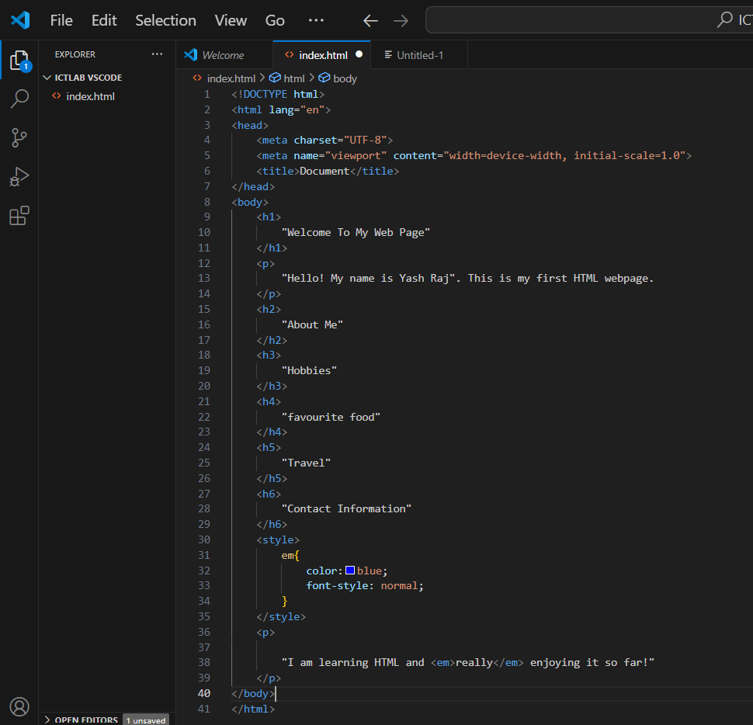

**Task#3 website view:-**

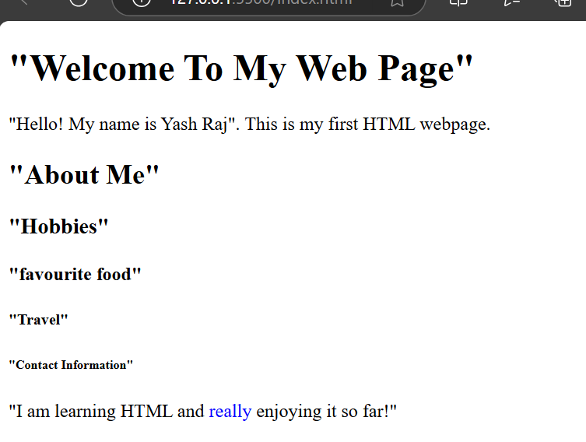

**TASK#4:-**

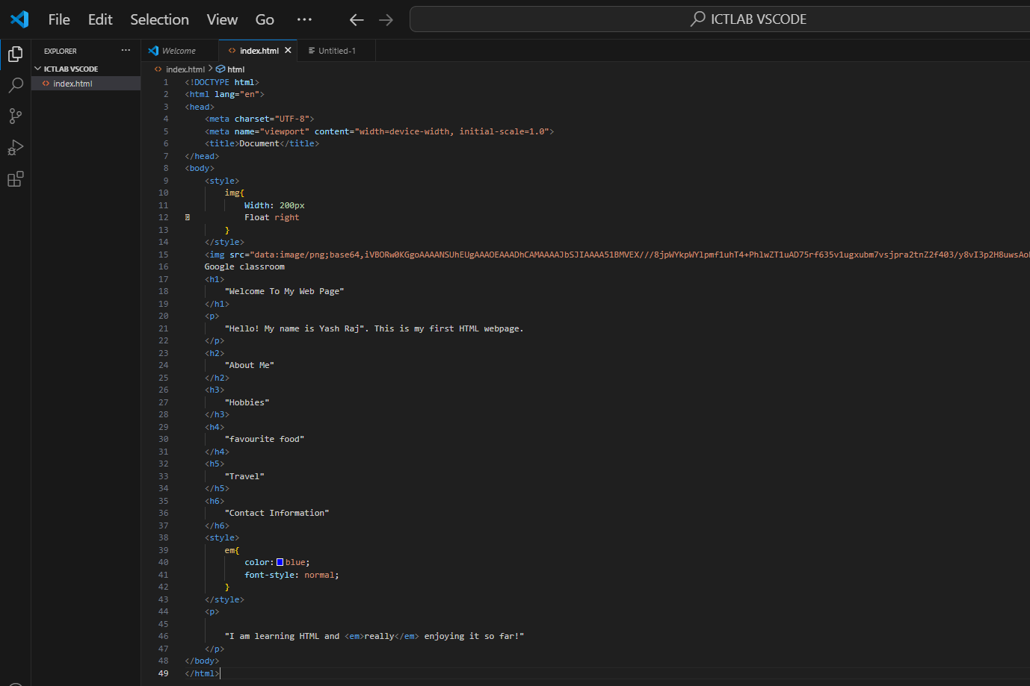

**Task#4 website view:-**

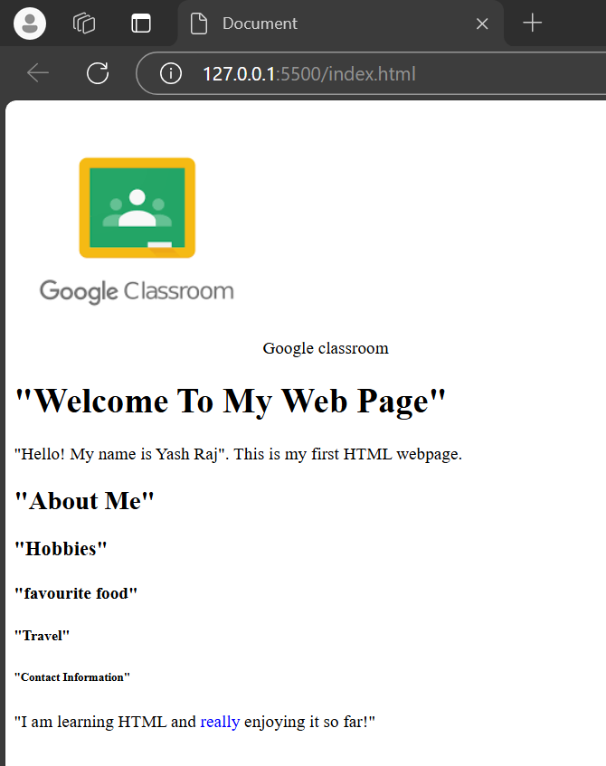

**TASK#5:-**

**PART1**

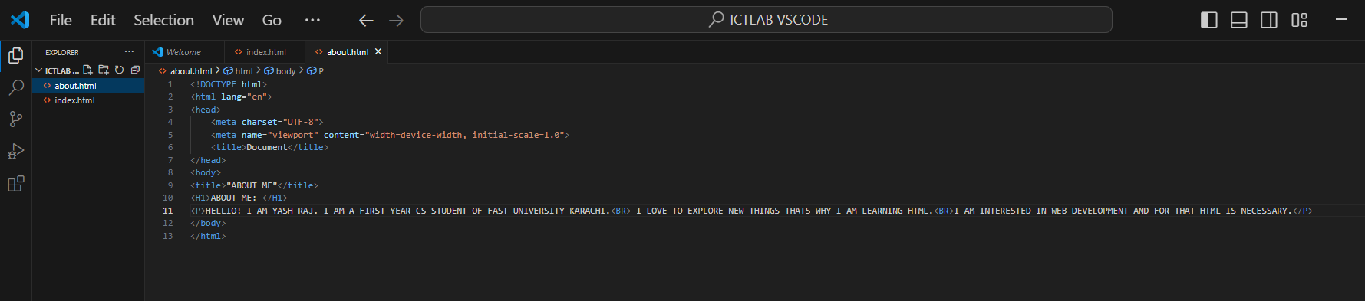

**Task#5 website view:-**

